**Answer all the following questions** .

Each question is followed by four options lettered A to D. Find out the correct option for each question and shade in pencil on your answer sheet the space which bears the same letter as the option you have chosen . Give only one answer to each question. An example is given below.

Natural science involves the study of the following except…………

1. Biology
2. Sociology
3. Chemistry
4. Geology

The correct answer is lettered **B** and therefore answer space **B**

Would be shaded.

[ A ] [**B**  ] [C ] [ D ]

Think carefully before you shade the answer space Erase completely any answer you wish to change. Do all rough work on this paper. Now answer the following questions

1. Which of the following ways of treating water makes it soft?
2. Addition of alum
3. Addition of washing soda
4. Filtration
5. Chlorination
6. A suitable machine for loading drums of palm oil onto a truck is ………
7. A screw
8. A crow bar
9. A wheel barrow
10. An inclined plane
11. Chlorination is an important step in water purification because it
12. Kills germs
13. Causes suspended particles to settle
14. Soften the water
15. Gives taste to the water
16. Soil moisture cannot be conserved by
17. Practicing mulching
18. Proper planning of irrigation systems
19. Addition of lime
20. Application of organic matter
21. The structure in the digestive system which produces enzyme is the ………….
22. Pancreas
23. Bile
24. Duodenum
25. Rectum
26. The disease that destroys the red blood cells resulting in anemia is ………..
27. Cholera
28. Malaria
29. Tuberculosis
30. Bird flu
31. Endangered species can be protected by …………
32. Having national parks and game reserves
33. Keeping record of all plants and animals
34. Encouraging the activities of chain –saw operators
35. Using bow and arrows for hunting
36. Which of the following types of water would contains the highest hardness?
37. Tap water
38. Sea water
39. Distilled water
40. Rain water
41. The sour taste of an unriped mango is due to its …………
42. Acidity
43. Alkalinity
44. Capillarity
45. Toxicity
46. Which of the following is not an effect drought
47. High farm yield
48. Low crop production
49. Bush fire
50. Migration

(11). Cowpeas is classified as

a. Cereals

b. Legumes

c. Tubers

d. Fruits

(12) Which of the following alloys is suitable for the construction of air craft?

a. Steel

b. Brass

c. Bronze

d. Duralumin

(13) The body process that results in the release of energy is …………..

a Digestion

b. Reproduction

c. Respiration

d. Growth

(14) Decay is an important biological process because it leads to the ……………..

a. Formation of nutrients in living organisms

b. Manufacture of cells in living organisms

c. Production of oxygen by plants

d. Release of nutrients from dead organisms

(15) In the p-n junction below the effect produced is …………….

P – type N - type

(+) terminal (-) terminal

1. Forward bias
2. Reverse bias
3. Neutral bias
4. Zero bias

(16) Which of the following does not use transistor?

a. Computer

b. Radio

c. Television

d. Pressing iron

(17) Oxygenated blood from the lungs enter the heart through the

a. Pulmonary vein

b. Pulmonary artery

c. Aorta

d. Vena cava

(18) An orange fruit falling from a tree possesses

a. Sound energy

b. Heat energy

c. Kinetic energy

d. Chemical energy

(19) The work output of a machine was 800J. If the work in put was 1000J.

What is the efficiency of the machine?

1. 50%
2. 60%
3. 70%
4. 80%

(20) Digestion of food is aided in the body by substances called

a. Enzymes

b. Hormones

c. Plasma

d. Vitamins

(21) The chlorophyll in the leaves of plants ………….

a. Provides energy for photosynthesis

b. Is the site for photosynthesis?

c. Controls the amount of gases entering the leaves

d. Traps energy from sunlight for photosynthesis

(22) How many atoms are present in Zn (NO**3**)**2**?

a. 3

b. 8

c. 9

d. 5

(23) One destructive effect of high humidity on agriculture is the

a. Increase in rate of transpiration

b. Increase in spread of diseases in plants and animals

c. Reduction in the rate of decay in dead plants and animals

d. Provision of energy for photosynthesis

(24) A stone of mass15g displaces 3.0cm**3** of water when completely immersed. Calculate its density

a. 7.0gcm**-3**

b. 45.0gcm**-3**

c. 5.0gcm**-3**

d. 10.0gcm**-3**

(25) The circulatory system consists of the …………

a. Mouth, stomach and intestines

b. Brain, spinal cord and nerves

c. Heart, blood and blood vessels

d. Heart. lungs and kidneys

(26) An element has 11 protons and 12 neutrons. The total negative charges in the atom is

a. 11

b. 12

c. 23

d. 1

(27) The force between the walls of a water container and the molecules of water in it is called

a. Adhesive force

b. Cohesive force

c. Capillary action

d. Surface tension

(28) Tooth decay is caused by

a. Virus

b. Bactria

c. Fungus

d. Protozoa

(29) There was attraction when two ends of metals suspected to be magnets were brought together.

The two ends are likely to be

a. NN poles

b. SS poles

1. NS poles

d. NE poles

(30) When testing for protein in a food substance using millions reagent. The expected colour change is

a. Blue –black

b. White

c. Deep red

d. Violet

(31) The following characteristics are features of all living things except the ability to

a. Bring forth young ones

b. Remove waste substances from their bodies

c. Grow in size and height

d. move from one place to place

(32) The release of eggs from the ovaries into the fallopian tube is called

a. Menstruation

b. Ejaculation

c. Ovulation

d. Copulation

(33) Sperms are stored in the

a. Penis

b. Epididymis

c. Testes

d. Sperm duct

(34) Which of the following farming systems is most suitable for densely populated area?

a. Land rotation

b. Mono cropping

c. Corp rotation

d. Shifting cultivation

(35) Electrons found in the outermost shell of an atom are called

a. Valence electrons

b. Noble gas electrons

c. Outside electrons

d. Stable electrons

(36) The periodic table is an arrangement of elements according to their ……………

a. Atomic number

b. Mass number

c. Neutron number

d. Weight

(37) Gold is used to make jewellery because it is ……………

a. Non – reactive

b. A metal

c. A non –metal

d. Reactive

(38) When bread is chewed for a long time it tastes sweeter because it ……………

a. Is made from sugar and flour

b. Is digested into simple sugar

c. Mixes with saliva which is alkaline

d. Is broken into smaller piece

(39) The sweet scent of perfume applied by student quickly spreads to all corners of the class room. This is due to the scientific process of ………………..

a. Distillation

b. Osmosis

c.. Diffusion

d. Capillarity

(40) An ion is an ………………..

a. Atom that has gained or lost electrons

b. Atom that has more protons than neutrons

c. Atoms that has equal number of electrons and protons

d. Atoms that has gained or lost protons

**PART 1**

**[40 MARKS]**

**ANSWER ALL OF QUESTION 1**

1. (a) The diagram below is used to demonstrate a phenomenon of light.

Study it carefully and use it to answer the question that follows

O Observer

Candle A B C

1. What phenomenon is being investigated?
2. What would the observer see? Explain why that observation is possible
3. If the Centre card is shifted slightly side wards, state and explain what observation would be made.
4. If a plane glass was placed between the light and card B , state and explain what observation would be made.
5. If another card without a hole was placed between the cards and the light state and explain what the observation would be made.
6. A coloured plastic was placed in front of the lighted candle.

State and explain what the observation would be.

(b) Study the simple electrical circuit below carefully and answer the questions that follow

I II

A

VI V

V

IV

(i ) Identify the parts labeled I, II, III, IV, V and VI.

(ii) Give the function of each of the parts I, II, III, IV, V and VI.

(iii) What energy changes occurs when the circuit is closed?

(iv) What observation is made when the circuit is closed?

(v ) What type of circuit connection is between IV and V? (10 Marks)

(c) The set-up below was used to demonstrate the importance of a factor in photosynthesis.

Study the experimental set-up below carefully and answer the questions.

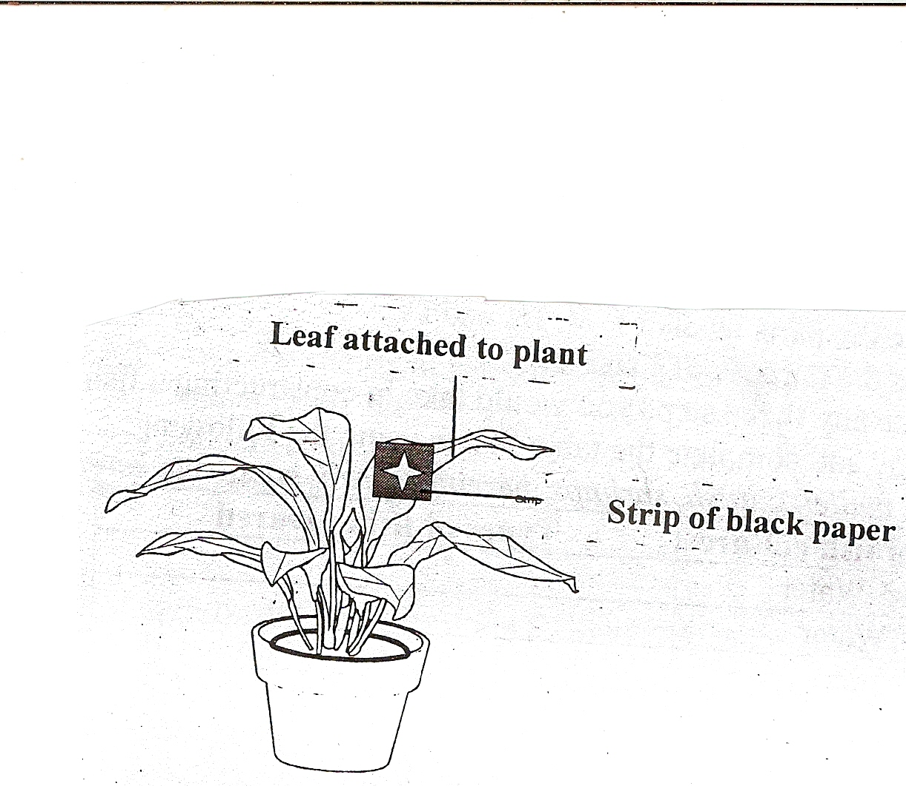

1. What is the aim of the experiment?
2. What Is the purpose of the strip of black paper?
3. Why were some parts of the leaf not covered?
4. Why did the leaf remain attached to the parent plant?
5. What will be the result when the leaf is tested for starch?
6. What conclusion can be drawn from the result (10mks)

(d) The diagram below shows a method of magnetizing a nail.

Study the diagram and use it to answer the questions that follow.

S

N

1. Name the method of magnetization used
2. State three important steps involved in the process.
3. How would you verify that the nail has been magnetized?
4. Describe the nature of the new magnet.
5. How would you test for the north and south poles of the new magnet?
6. List two substances that can be made into a magnet.
7. State two other method of making magnets
8. State the law of magnetism.

PART II

**Answer four questions only from this part**

1. (a) (i) Describe how the following factors lead to the depletion of soil resources.

(&) Leaching

(ß) Burning of vegetation

(Y) Over – Cropping

(ii) Give two ways we can conserve soil water

(iii) Describe how mulching is carried out on the form (5mks)

(b) (i) Give two characteristics of a chemical change.

(ii) Describe the chemical changes that occurs in the following:

(&) Fermentation of palm-wine

(ß)Rusting of iron

(Y)Chewing of bread

(iii) Write balance chemical equation for the following:

( &)Iron reacts with sulphur to produce iron (II) Sulphide.

(ß) Charcoal burns in air to produce carbon (II) Oxide.

( Y) hydrogen chloride reacts with sodium hydroxide to produce sodium chloride and water (4mks)

C (i) Explain what happens when:

(a) Light from the sun hits the earth surface.

(B) A ray of light passes through a triangular glass prism.

(Y) Light rays travelling through the air enters water.

(ii) A ray of light hits the surface of a plane mirror at angle of 65**0**. Draw a ray diagram for the phenomenon. (3mks)

(d) (i)Identify two ways in which plants defend themselves against attack.

(ii) State two ways in which animals defend themselves against attack. (3mks)

(3) (ai) What is a P-n junction diode?

(ii) Explain what it means when a p –n junction is:

(&) Forward bias

(ß)Reverse bias

(iii) With the aid of diagram only differentiate between PNP transistor and NPN transistor. (5mks)

(b) (i) What is an acid?

(ii) State four properties of acids

(iii) Dilute hydrochloric a acid reacts with calcium hydroxide to produce salt and water. Write down a balanced chemical equation for the reaction. (4mks)

( c) (i) What is a living organism?

(ii) Give two reasons why the sun is not a living organism.

(iii) State two characteristics of living organisms. (3mks)

( d) (i) Explain why a slim young lady, wearing stiletto heels exerts a much larger pressure on the ground than an elephant does.

(ii) Give four reasons why friction is important in every life (3mks)

(4) (a) Copy and complete the table below.

|  |  |  |
| --- | --- | --- |
| DIGESTIVE ENZYMES | SOURCE | ROLE IN DIGESTION |
| Pepsin | (i) …………………………. | (ii) ………………………… |
| Trypsin | (iii)………………………… | (iv)………………………… |
| (v) ………………………… | Saliva in the mouth | (vi)………………………… |

(b ) (i) An atom has an atomic number of 11 and a mass number of 23. State the number of:

( &) Protons (B) Electrons (Y) Neutrons

(ii)Draw to show the electronic structure of the atom above (3mks)

( C) (i) What is friction?

(ii) Give two disadvantages of friction

(iii) State any two ways of reducing friction. (4mks)

( d) (i) State three differences between protons and electrons

(ii) Explain why atoms are electrically neutral.

(iii) Give two properties of good drinking water (5mks)

(5) (a) (i) Give two differences between a seed and a fruit.

(ii) List two differences between red blood cells and white blood cells.

(b) Write the name and chemical formula of the compounds formed when the following elements combine

(i ) Sodium and chlorine.

(ii) Calcium and oxygen

( c) (i) Define these terms:

(a ) Potential energy (b)Kinetic energy.

(ii) A boy of mass 70kg climbed a tree of height 4.2m. What is the potential energy of the body? (g = 10m / 5**2**)

(iii) A stone of mass 0.45kg was fired with a catapult. The stone moved with a velocity of 3.oms **-1**.

Calculate the kinetic energy of the stone.

( d) (i) What is a satellite?

(ii) Give two differences between a natural satellite and artificial satellite.

(iii) Write down two uses of artificial satellite

(6) (a) (i) What is a food web?

(ii) Mention two ways in which plants and animals are interdependent in a food web.

(b ) (i) Give two differences between condensation and sublimation.

(ii) State four factors which affects the rate of evaporation of a liquid (4mks)

( c) List four benefits that the nation derives from agriculture (4mks)

( d) Write down the chemical formula of each of the following compounds.

( i) Iron (II) Sulphide

(ii) Calcium hydroxide

(iii) Copper (II) Oxide (3mks)

MARKING SCHEME FOR INTERGRATED SCIENCE

1.B 16.D 31.D

2.D 17A 32.C

3.A 18.C 33.B

4.C 19.D 34.C

5.A 20.A 35.A

6.B 21.D 36.A

7.A 22.C 37.A

8.B 23.B 38.B

9.A 24.C 39.C

10.A 25.C 40.A

11.B 26.A

12.D 27.A

13.C 28.B

14.D 29.C

15.A 30.C